The Victor

Teardown and Review by Lee Bussy, August 13, 2021

[The Victor](http://www.greenbeehives.com/thevictor.html) is sold by [GreenBeehives.com](http://www.greenbeehives.com/) for $237.00 for the 8 or 10-frame variety. The system is optimized for 12VDC operation to be powered by a 12-volt deep-cycle battery.

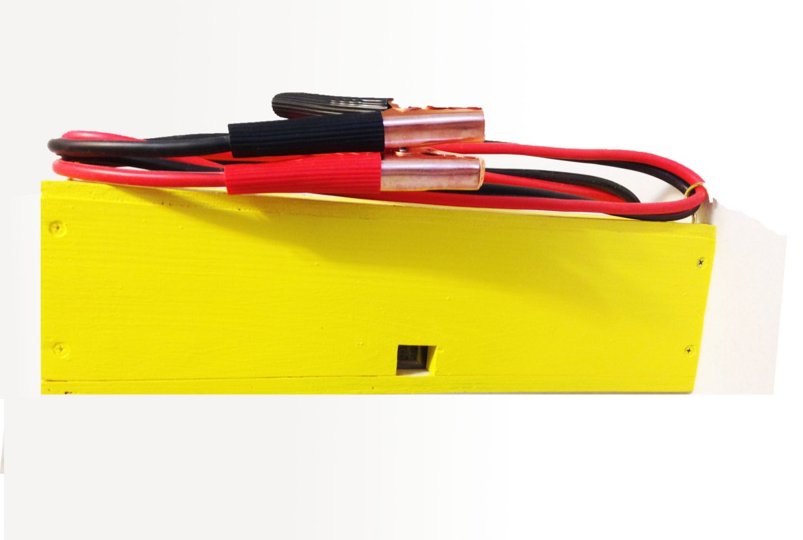

Figure : The Victor, end view, from manufacturer's website

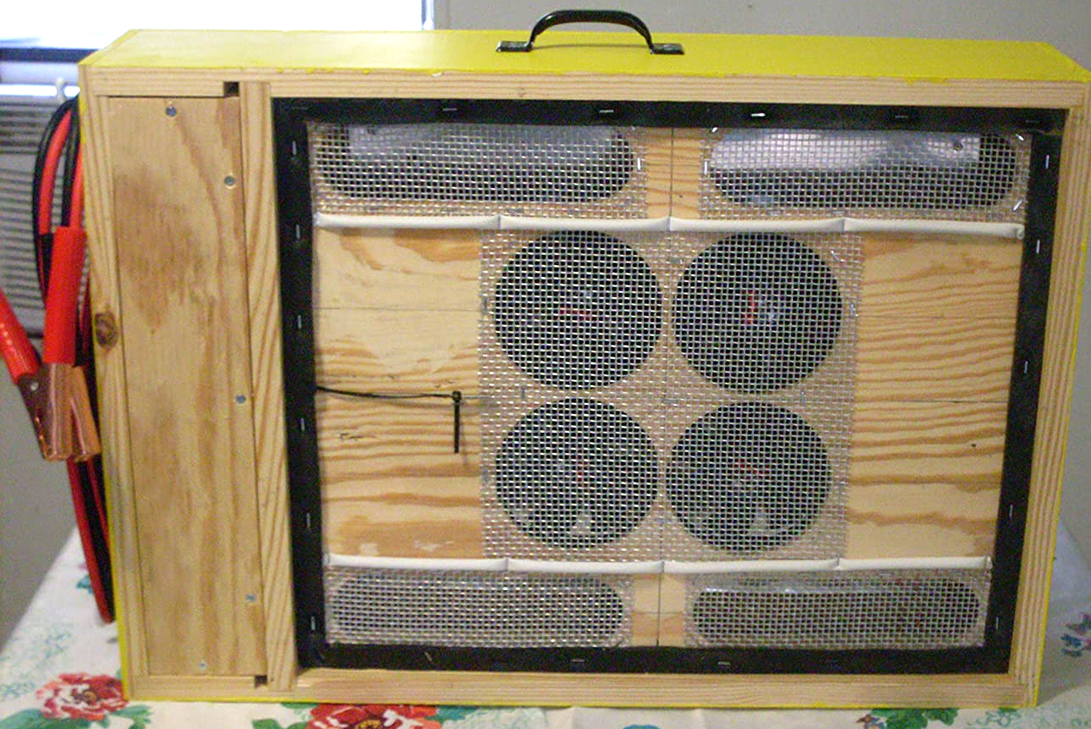

Figure : The Victor, bottom view

# Overview

The Victor uses a commodity device which is a combination of heat control, timer, and relay. It leverages an additional high current relay to control the heat. Fans are used to move the air to supplement a convective pattern, and the heater itself is a plate device within the box. During typical use, no adjustments are required.

From the manufacturer:

It heats the brood area to 42 degrees Centigrade (107F), which kills 85% of the mites on adult bees and in the capped brood while not harming the bees with one 2.5 hour treatment. […] To use the Victor, […] connect a 12v 55Ah battery to its leads. The heater will start to heat, the fans will blow, and the thermostat will show the current temperature and the target temperature in centigrade. […] The thermostat will maintain the temp for 3 hours then automatically shutoff.

# BOM

This BOM represents what would be required to reproduce the product. Some reasonable replacements have been made.

* Controller: $2.23
* Relay Board: $1.80
* Heating Element: $4.97
* 4 x 120mm Fans: $29.28
* Jumper cables: $5.62

Total for major components: $43.90

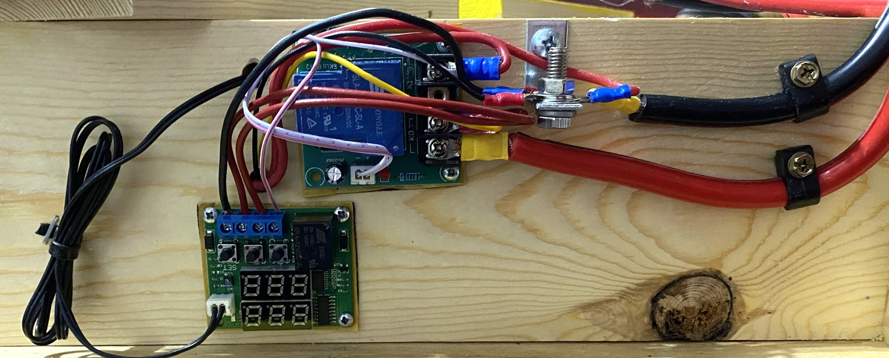

Figure : Controller Area of The Victor

In addition to these components, other everyday items such as wires, terminals, wood, and hardware cloth are used.

## Temperature Controller

The brains of the box appear to be a China-sourced temperature controller with an NTC sensor and 20A 14DVC relay:

[W1219 DC 12V Dual LED Digital Thermostat Temperature Controller temperature Regulator Switch Control NTC 10K Sensor Module](https://www.aliexpress.com/item/32972182649.html) (multiple versions, choose dual-display) - $2.23 at the time this research was done.

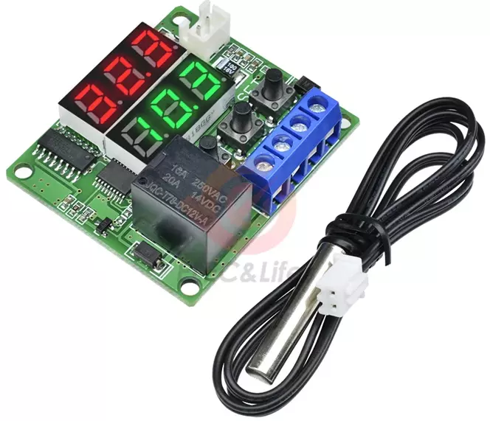

Figure : W1219 Temperature Controler and Probe

[The same item was seen on Amazon Prime](https://smile.amazon.com/dp/B076Y5BXD9) for $11.99.

## Power Relay

Likely because the current load is close to the rated maximum for this board. The relay on the board is a [Power Relay SLA-12VDC-SL-A 30A 240VAC 5PIN T90](https://www.aliexpress.com/item/1005001303743331.html), $0.44 when this research was done.

The relay is part of a high-current relay board assembly: [30A 250V high current switch board normally closed relay board 12V input switch control 30A output](https://www.aliexpress.com/item/32836138463.html), $1.80 at the time this research was done.

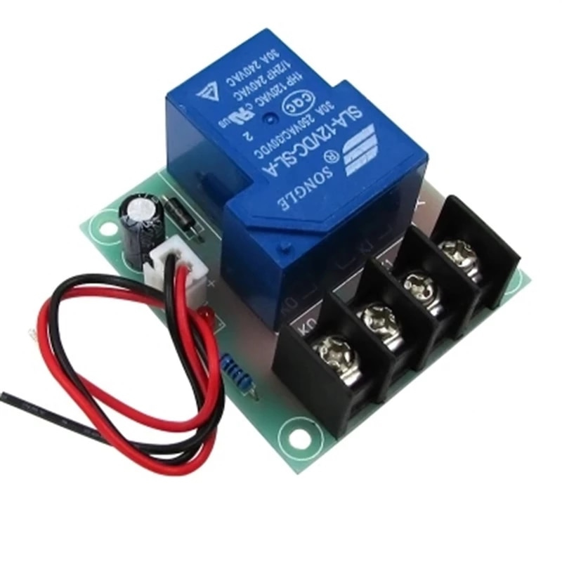

Figure : Secondary high-current relay

[The same item was seen on Amazon Prime](https://smile.amazon.com/Yeeco-Contactor-Switching-electrical-switches/dp/B00MKWACVI/139-2217245-4741669) for $10.99.

## Heat Plate

The heat plate is a commodity-type flat resistance heater mounted upon an aluminum sheet. These are sold for many purposes, including pipe wraps and 3D printer heat beds. The 12VDC application for these is not typical. Any DC heater could likely be applied with attention to the wattage.

Observed characteristics:

* 12DVC
* 0.8Ω
* 180W
* 15A

3D printer heat beds are often 24VDC; a 180W bed would have the following characteristics in a 24VDC version:

* 24DVC
* 2.3Ω
* 180W
* 7.5A

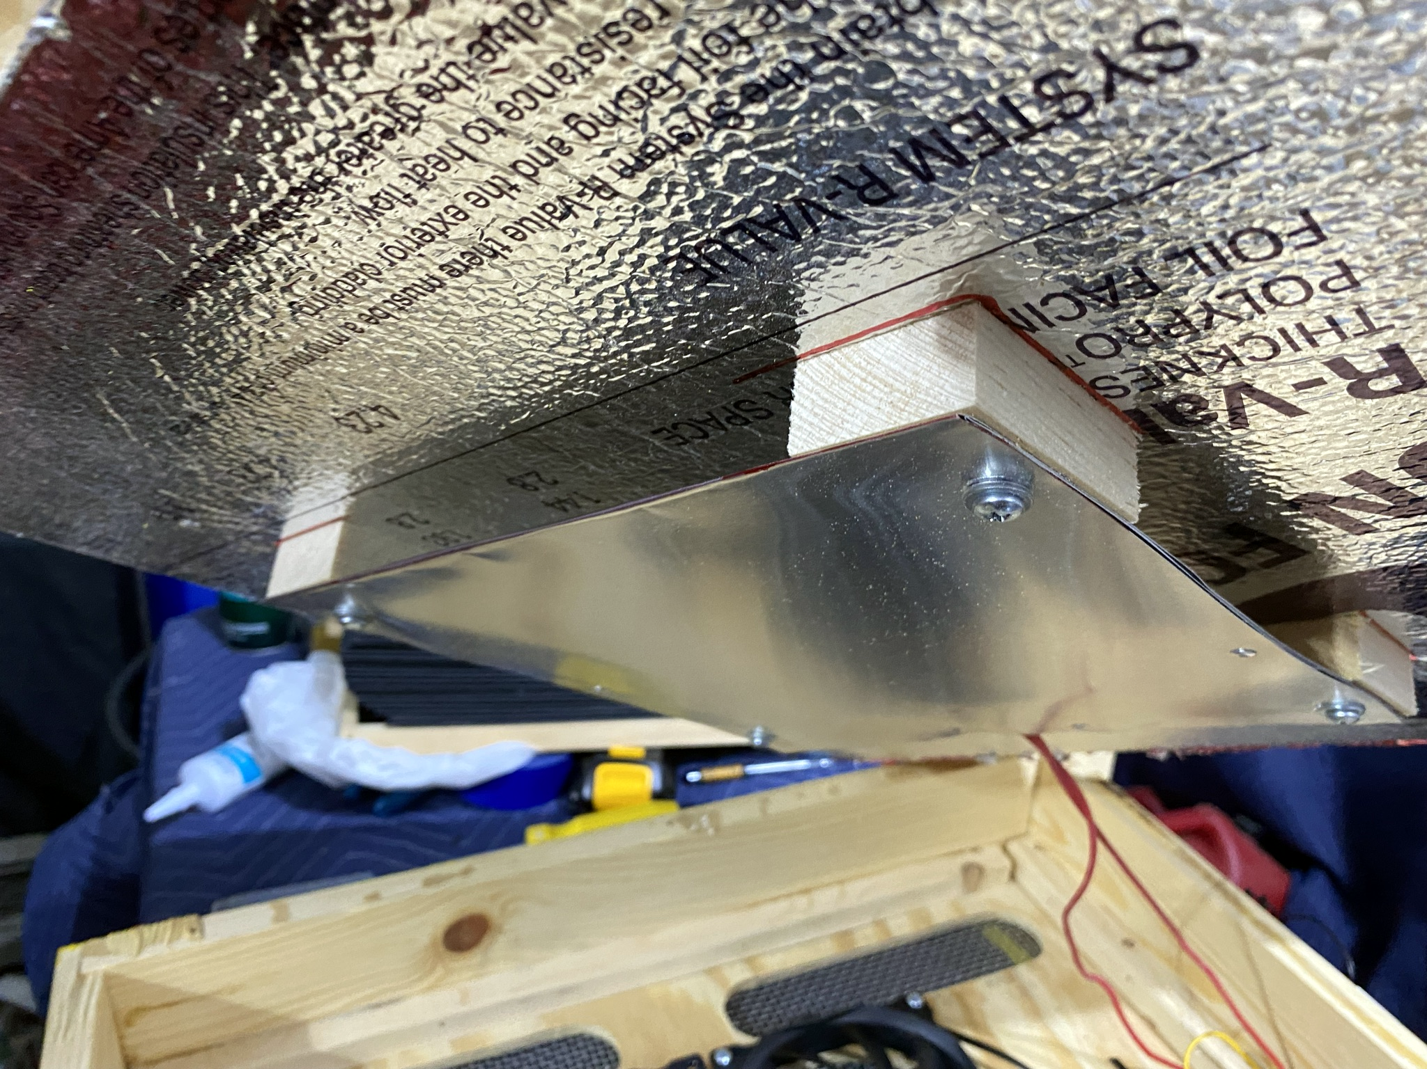

Figure 6: Heating pad and aluminum radiation plate

The heater appears similar to a [150x150mm 180W 12V Silicone Heater Pad](https://www.aliexpress.com/item/32349861003.html), $38.54 when this research was done. It looks to be bonded to an aluminum plate, mounted to the case via wooden stand-offs. In this application, the sensor leads would not be used.

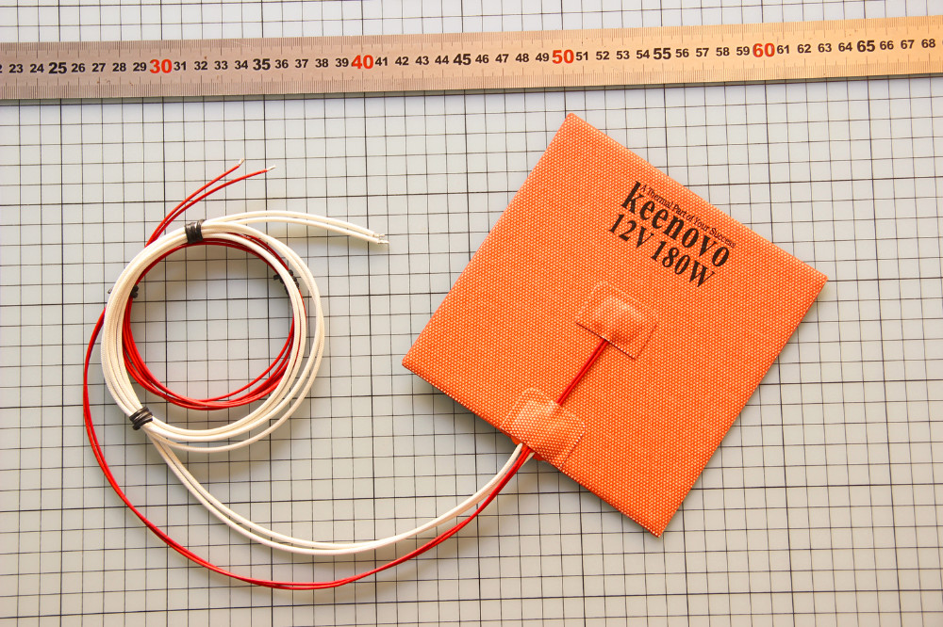

Figure : Silicone Heater Pad

Other form factors are available which could provide similar results. PTC heaters, specifically, would be a good choice.

Positive Temperature Coefficient (PTC) heaters are self-regulating heaters that run open-loop without any external diagnostic controls. While traditional fixed-resistance heaters employ wires and coils to generate heat, PTC heaters use conductive inks printed on thin, flexible polymer-based substrates. They are ideal for products that require safer, faster, and more uniform heating. The material properties allow the PTC heater to act as its own sensor, eliminating the need for any external feedback controls. As a result, the heater inherently removes the risk of overheating.

Assuming the same heat density: a 120°C (248°F) aluminum PTC in 12VDC/180W capacity [77x62x6mm 12V 30W ~180W Thermostat Insulation Aluminum PTC Heater Element](https://www.aliexpress.com/item/32969999641.html) may be purchased for $4.97.

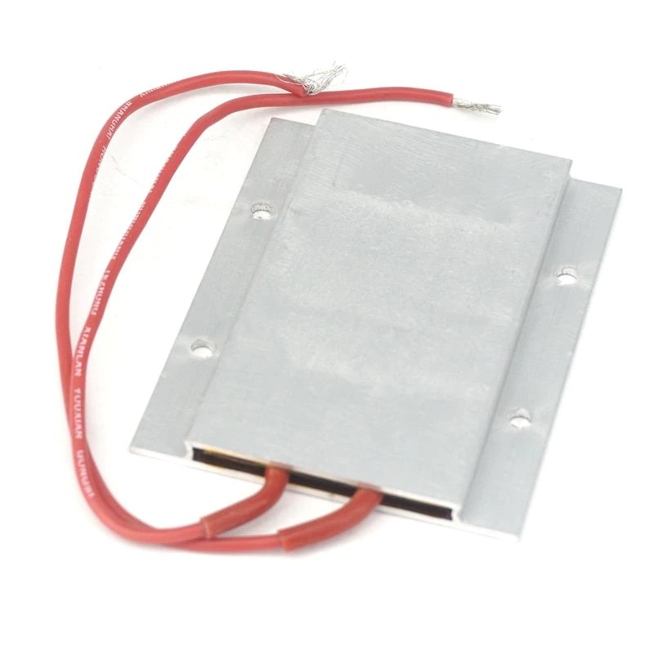

Figure : Aluminum PTC Heater Plate

## Fans

120mm 12VDC fans are ubiquitous, and no particular brand or configuration is required. The exact brand and model of the fans used in this device are the [uphere 3-Pack Long Life Computer Case Fan 120mm Cooling Case Fan for Computer Cases Cooling,12BK3-3](https://www.amazon.com/uphere-3-Pack-Computer-120mm-Cooling/dp/B072LDYKQ6), which is $12.99 for a three-pack on Amazon Prime.

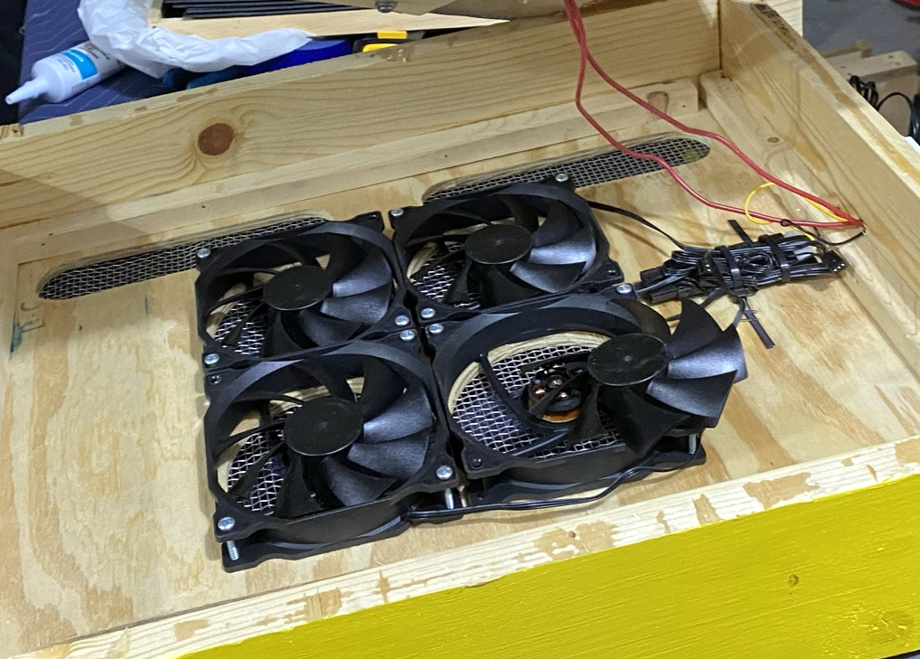

Figure : Computer Case Fan 120mm

*Four fans are used in this device. The cost of $17.32 is calculated based on the price of four fans when purchasing at the three-pack price.

Splitters for three-wire fans are widely available and may make wiring them easier. Such a bundle may be seen in the right side of this image.

For this price point, these fans are a reasonable choice. These are three-wire fans intended to be used on computer motherboards to sense fan speed via the third wire. This speed sensing is not used nor necessary for this application. The black or plain wire is ground, and the red or striped wire is the + DC voltage supply.

A replacement [12V Sleeve/Ball Cooling Fan 120x120x25mm 2PINDC Cooler Fan for PC Computer Case](https://www.aliexpress.com/item/4001262716733.html) may be purchased for $7.32.

# Closing

Credit for the realization that temperatures may control the Varroa mite belongs to the academic community. Randy Oliver published his findings in The American Bee Journal in [March](https://scientificbeekeeping.com/a-test-of-thermal-treatment-for-varroa-part-1/) and [April](https://scientificbeekeeping.com/a-test-of-thermal-treatment-for-varroa-part-2/) of 2021.

No determination is made of the efficacy of this device related to its ability to reach and maintain temperatures.